CONTEXT-AWARE INDOOR STAFF PRESENCE VERIFICATION USING BLE

A PROJECT REPORT
Submitted by

BHARATHI KANNAN P (953122104018) IMAN RAJA R (953122104029)
KRISHNAKUMAR M (95072012042)
LAKSHMANAN N (953122104044)

in partial fulfillment for the award of the degree of

BACHELOR OF ENGINEERING
in

COMPUTER SCIENCE AND ENGINEERING

THAMIRABHARANI ENGINEERING COLLEGE

(Autonomous)
TIRUNELVELI –627 003

APRIL 2024

THAMIRABHARANI ENGINEERING COLLEGE
(Autonomous) TIRUNELVELI 627 003

BONAFIDE CERTIFICATE

Certified that this project report “Context-Aware Indoor Staff Presence Verification Using BLE” is the bonafide work of “BHARATHI KANNAN P (953122104018), IMAN RAJA R (953122104029), KRISHNAKUMAR M (953122104042), LAKSHMANAN N (953122104044)” who carried out the project work under my supervision. Certified further that to the best of my knowledge the work reported herein does not form part of any other thesis or dissertation on the basis of which a degree or award was conferred on an earlier occasion on this or any other candidate.

SIGNATURE SIGNATURE

Mrs. Y. ROJA BEGAM, M. E., Dr.G.Aravind Swaminathan M.E.,Ph.D SUPERVISOR, HEAD OF THE DEPARTMENT,
Assistant Professor, Professor,
Department of CSE, Department of CSE,
Thamirabharani Engineering College,
Tirunelveli-627003
Thamirabharani Engineering College, Tirunelveli – 627003 Tirunelveli – 627003

Submitted for the B.E Degree Project Viva Voce held on …………………………………

INTERNAL EXAMINER EXTERNAL EXAMINER

ACKNOWLEDGEMENT

It gives us immense pleasure and satisfaction in presenting this report of the project undertaken during the final year of B.E. As it is the first step into our Professional Life, we would like to take this opportunity to express our sincere thanks to several people, without whose help and encouragement, it would have been impossible for us to carry out the desired work.
We would like to express our sincere thanks to our Chairman Dr.S.Cletus Babu, Principal Dr.V.Velmurugan and Head of Department Dr.G.Aravind Swaminathan from the bottom of our heart, who gave us an opportunity to undertake such a great challenging and innovative work.
The gratitude is also extended to Mr.S.Malaiarasan, Assistant Professor, Computer Science and Engineering Department for sharing his pearl of wisdom with us during the course of development of this project.
We place on record our sincere thanks to Professor Dr. L.R Priya for being a constant source of motivation for us. By her uncompromising demand for quality and her insistence for meeting the deadlines, we could do such excellent work.
We would like to thank all faculty members of our college, our friends and our family members for providing their support and continuous encouragement throughout the project.
Finally, we thank our college Francis Xavier Engineering College for providing us with a supporting environment. We thank them for providing us such a warm atmosphere to make our Project work development experience delightful and
memorable.

ABSTRACT

This project presents a context-aware indoor staff presence verification system using Bluetooth Low Energy (BLE) technology. In modern organizations, tracking staff attendance and presence accurately within indoor environments is a major challenge due to the limitations of traditional systems such as biometric or RFID-based solutions. The proposed system leverages BLE beacons and mobile devices to detect and verify the presence of staff members in real time. BLE signals are captured and analyzed to determine proximity, enabling precise indoor localization and presence validation. The system integrates context-awareness by considering environmental and temporal factors such as signal strength, movement patterns, and location zones. A machine learning-based classification approach is employed to distinguish valid staff presence from anomalies or spoofing attempts. The system is tested in a controlled indoor environment, and experimental results demonstrate high accuracy in detecting and verifying staff presence.
This project contributes to smart workplace automation by providing a scalable, low-cost, and energy-efficient solution for indoor presence verification, improving security, attendance monitoring, and operational efficiency.

 | TABLE OF CONTENTS
CHAPTER | TITLE | PAGE NO
 | ACKNOWLEDGEMENT | iii
 | ABSTRACT | iv
 | LIST OF FIGURES | viii
 | LIST OF ABBREVIATIONS | viii

1. |  | INTRODUCTION | 1
1.1 | Brain Tumor Detection using MRI |  | 1
1.2 | SIFT and SVM in Brain Tumor Detection |  | 3
1.3 | History of SIFT and SVM in Brain Tumor Detection |  | 5
1.4 | Applications of SIFT and SVM in Brain Tumor Detection |  | 6
1.5 | Difficulties in Brain Tumor Detection |  | 8
1.6 | Methodologies |  | 9
1.6.1 | Data Acquisition |  | 9
1.6.2 | Pre-processing |  | 10
1.6.3 | SIFT Feature Extraction |  | 11
1.6.4 | SVM Classification |  | 13
1.6.5 | Confusion Matrix |  | 16
1.6.6 | Tools and Technologies |  | 18
1.6.6.1 |  | MATLAB R2023 B | 18
1.6.6.2 |  | Image Processing | 19
1.6.6.3 |  | Image Segmentation | 19

2. | LITERATURE REVIEW | 20
2.1 | Project | 21

 | 2.1.1 | Image Segmentation for MR Brain Tumor Detection Using Machine Learning | 21
 | 2.1.2 | Brain Tumor Classification and Detection Based  DL Models | 21
 | 2.1.3 | A Deep Learning Model Based on Concatenation  Approach for the Diagnosis of Brain Tumor | 22
 | 2.1.4 | A Robust Approach for Brain Tumor Detection in Magnetic Resonance Images Using Finetuned EfficientNet | 23
 | 2.1.5 | A VGG Net-Based Deep Learning Framework for Brain Tumor Detection on MRI Images | 24
 | 2.1.6 | Optimized Edge Detection Technique for Brain Tumor Detection in MR Images | 25
 | 2.1.7 | Deep Learning Based Brain Tumor Detection and Classification | 25
 | 2.1.8 | Effective Algorithm for Benign Brain Tumor Detection Using Fractional Calculus | 26
 | 2.1.9 | Human Brain Tumor Detection Using CPW Fed UWB Vivaldi Antenna | 27
 | 2.1.10 | Comparison of VGG-19 and RESNET-50 Algorithms in Brain Tumor Detection | 27
2.2 |  | SUMMARY | 28

3. | PROPOSED SYSTEM | 29
3.1 | IMPLEMENTATION | 29
3.1.1 | Literature Survey Observation | 29
3.1.2 | Existing Systems | 30
3.1.3 | Proposed System | 30
3.1.4 | Dataset Collection | 30
3.1.5 | Training SVM Model | 31
3.1.6 | Testing and Evaluation | 32
3.1.7 | MATLAB Implementation | 33

3.2 | SYSTEM REQUIREMENTS | 34
3.2.1 | Minimum | 34
3.2.2 | Recommended | 35
3.2.3 | Software Requirements | 35
3.3 | LANGUAGES USED | 35
4 | SYSTEM ARCHITECTURE | 36
4.1 | Block Diagram | 36
5 | RESULTS | 37
6 | CONCLUSION & FUTURE SCOPE | 41
7 | APPENDIX | 43
7.1 | Sample Code | 43
7.2 | Sample Screenshots | 53
8  9 | REFERENCES  Publication | 55  57

LIST OF FIGURES

FIGURE  NO. | NAME OF THE FIGURE | PAGE  NO.
4.1  5.1 | Block Diagram Original MRI Image | 36  37
5.2 | Histogram | 37
5.3 | SIFT Extraction | 38
5.4  5.5  5.6 | Feature Extraction  Classification  Confusion Matrix | 38  39  39
7.2.1 | Testing code 1 | 53
7.2.2 | Testing code 2 | 53
7.2.3 | Training code 1 | 54
7.2.4 | Training code 2 | 54

LIST OF ABBREVIATIONS

ACRONYMS  MATLAB  MRI  CT  CNN  SVM  SIFT  CNS | ABBREVIATIONS  Matrix Laboratory  Magnetic Resonance Imaging  Computed Tomography  Convolutional Neural Network  Support Vector Machine  Scale Invariant Feature Transform  Central Nervous System

CHAPTER 1 INTRODUCTION
1.1 Introduction to Indoor Presence Verification
Indoor presence verification is the process of detecting and confirming whether an individual is physically present within a specific indoor environment such as an office, classroom, laboratory, hospital, or industrial workspace. In modern organizations, accurate monitoring of staff presence plays a vital role in attendance management, security enforcement, and efficient resource utilization.
Traditional methods of presence verification, such as biometric systems and Radio Frequency Identification (RFID) cards, are widely used but have several limitations. These systems typically record attendance only at entry or exit points and do not provide continuous monitoring of individuals within the indoor environment. Additionally, they are susceptible to misuse, such as proxy attendance, and often require costly infrastructure and maintenance.
With the advancement of wireless communication technologies, there is a growing need for more efficient and automated systems that can provide real-time presence verification. Bluetooth Low Energy (BLE) has emerged as a promising solution due to its low power consumption, cost-effectiveness, and widespread compatibility with mobile devices.
In a BLE-based system, small devices known as beacons continuously transmit signals that can be detected by nearby smartphones or IoT devices. The strength of these signals, referred to as the Received Signal Strength Indicator (RSSI), is used to estimate the proximity of a user to a particular location. By analyzing these signals, the system can determine whether a person is present within a defined indoor area.
Furthermore, the integration of context-aware techniques enhances the accuracy and reliability of presence verification. By considering factors such as time duration, movement patterns, and signal stability, the system can distinguish between actual presence and false detections caused by environmental interference.
Overall, indoor presence verification using BLE provides a scalable, cost-effective, and efficient solution for real-time monitoring of individuals in indoor environments. This approach overcomes the limitations of traditional systems and enables smarter, automated, and more reliable presence detection in modern applications.

1.2 Overview of BLE Technology
Bluetooth Low Energy (BLE) is a wireless communication technology designed for short-range data transmission with minimal power consumption. It is a part of the Bluetooth standard introduced to support applications that require energy efficiency and continuous operation, such as wearable devices, healthcare systems, and Internet of Things (IoT) applications.
Unlike traditional Bluetooth, which is designed for high data rate communication, BLE focuses on transmitting small amounts of data while consuming significantly less power. This makes it highly suitable for battery-operated devices that need to function for extended periods without frequent recharging.
BLE operates using a broadcasting mechanism where devices known as beacons continuously transmit signals at regular intervals. These signals can be detected by nearby devices such as smartphones, tablets, or embedded systems. Each beacon transmits unique identification information, which allows the receiving device to recognize and differentiate between multiple beacons deployed in an environment.
One of the key parameters used in BLE-based systems is the Received Signal Strength Indicator (RSSI). RSSI represents the strength of the signal received from a beacon and is commonly used to estimate the distance between the transmitting beacon and the receiving device. A stronger signal typically indicates closer proximity, while a weaker signal suggests a greater distance.
BLE technology offers several advantages that make it ideal for indoor presence verification systems. It is cost-effective, easy to deploy, and widely supported by modern smartphones and IoT devices. Additionally, BLE provides sufficient accuracy for indoor localization when combined with appropriate signal processing and machine learning techniques.
However, BLE signals can be affected by environmental factors such as walls, obstacles, and interference from other electronic devices. These factors may cause fluctuations in RSSI values, which can impact accuracy. To address this, advanced techniques such as filtering, calibration, and context-aware analysis are often used.
In summary, Bluetooth Low Energy is a reliable and efficient technology for short-range wireless communication. Its low power consumption, ease of integration, and compatibility with existing devices make it a suitable choice for developing context-aware indoor presence verification systems.

1.3 Context-Aware Systems
Definition of Context-Aware Systems
A context-aware system is an intelligent computing system that can sense, interpret, and respond to information about its environment and user conditions. The term “context” refers to any relevant information such as location, time, user activity, environmental conditions, and device status that can influence system behavior.

Need for Context-Aware Systems
Traditional systems operate based on fixed inputs and predefined rules without considering surrounding conditions. This often leads to inaccurate or inefficient results. Context-aware systems overcome this limitation by dynamically adapting their behavior based on real-time information, thereby improving accuracy and system performance.

Role in Indoor Presence Verification
In the proposed indoor presence verification system, context-awareness enhances detection accuracy. Instead of relying only on BLE signal strength (RSSI), the system considers additional contextual parameters such as:
- Duration of presence
- Movement patterns
- Signal stability
- Time-based conditions
By analyzing these factors, the system can distinguish between actual presence and false detections caused by signal fluctuations.

Example of Context Awareness
For instance, if the signal strength temporarily decreases due to an obstacle, a normal system may assume that the person has left the area. However, a context-aware system analyzes the overall behavior over time and avoids making incorrect decisions.
Similarly, if a device remains in a particular location for a longer duration, the system confirms the presence with higher confidence.

Working Process of Context-Aware Systems
Context-aware systems generally follow three main steps:
1. Context Acquisition
In this stage, data is collected from sensors or devices such as BLE beacons. This includes signal strength, location data, and time information.
2. Context Processing
The collected data is analyzed using algorithms or machine learning techniques to identify patterns and extract meaningful information.
3. Context Adaptation
Based on the processed data, the system makes decisions such as confirming presence or ignoring false signals.

Advantages of Context-Aware Systems
- Improves accuracy of detection
- Reduces false positives and false negatives
- Enables intelligent decision-making
- Adapts to changing environments
- Enhances overall system reliability

1.4 Applications of BLE-based Presence Detection
Overview
BLE-based presence detection systems are widely used in various real-world applications due to their low power consumption, cost-effectiveness, and ability to provide real-time indoor tracking. These systems help automate processes, improve accuracy, and enhance operational efficiency across different domains.

1. Smart Office Systems
In smart office environments, BLE-based systems are used to automatically track employee attendance and movement within the workplace. BLE beacons are installed in different areas such as cabins, meeting rooms, and workspaces.
Employees carry smartphones or BLE-enabled devices that detect beacon signals. Based on signal strength, the system verifies their presence in specific zones.
Benefits:
- Automatic attendance marking
- Real-time employee tracking
- Improved workspace management
- Reduced manual effort

2. Healthcare Systems
In healthcare environments such as hospitals, BLE-based presence detection is used to monitor medical staff, patients, and equipment.
BLE beacons are deployed across wards, operation theatres, and emergency units. Staff and equipment are tagged with BLE-enabled devices for easy tracking.
Benefits:
- Quick identification of available doctors and nurses
- Efficient tracking of medical equipment
- Improved patient monitoring
- Faster emergency response

3. Educational Institutions
In schools and colleges, BLE-based systems are used for automated attendance management. Students carry smartphones or BLE-enabled ID cards.
When they enter the classroom, their presence is automatically recorded using BLE signals.
Benefits:
- Eliminates manual attendance process
- Prevents proxy attendance
- Saves classroom time
- Generates real-time attendance reports
4. Industrial Environments
In industries and factories, BLE systems are used to monitor workers and ensure safety in hazardous environments.
Beacons are placed in different sections, and workers carry BLE-enabled devices that allow real-time tracking.
Benefits:
- Tracks worker location in real-time
- Ensures safety in restricted areas
- Improves workforce management
- Supports emergency evacuation

5. Security and Access Control Systems
BLE-based presence detection is widely used in security systems to control access to restricted areas such as laboratories, server rooms, and confidential zones.
Only authorized users with registered devices are allowed entry, and their presence is continuously monitored.
Benefits:
- Enhances security and surveillance
- Prevents unauthorized access
- Maintains entry and exit logs
- Enables automated access control

1.5 Difficulties in Brain Tumor Detection
Overview
Although BLE-based indoor presence detection systems offer many advantages, achieving high accuracy in indoor environments is challenging. Various environmental and technical factors affect signal behavior, making it difficult to precisely determine user location and presence. Understanding these challenges is essential for designing reliable and efficient systems.

1. Signal Interference
Signal interference occurs when BLE signals are obstructed or weakened by physical objects such as walls, furniture, glass, and even human bodies.
Explanation:
BLE signals travel through the air, but indoor environments contain multiple obstacles that absorb or block signals. This leads to inconsistent signal strength, which affects distance estimation.
Impact:
- Incorrect presence detection
- Reduced accuracy
- Signal loss in certain areas

2. Multipath Propagation
Multipath propagation happens when BLE signals reflect off surfaces such as walls, floors, and ceilings before reaching the receiver.
Explanation:
Instead of taking a direct path, signals may arrive through multiple reflected paths, causing delays and variations in signal strength.
Impact:
- Confusion in distance calculation
- Unstable RSSI values
- Increased localization error

3. RSSI Variability
RSSI (Received Signal Strength Indicator) values are not stable and can fluctuate frequently even when the device is stationary.
Explanation:
Factors such as temperature changes, obstacles, device orientation, and interference from other signals can cause fluctuations in RSSI values.
Impact:
- Inconsistent readings
- False presence or absence detection
- Difficulty in accurate classification

4. Device Heterogeneity
Different devices (smartphones, tablets, IoT devices) may interpret BLE signals differently.
Explanation:
Each device has different hardware specifications, antenna designs, and sensitivity levels, leading to variation in RSSI readings even under the same conditions.
Impact:
- Inconsistent results across devices
- Reduced system reliability
- Need for device-specific calibration

5. Environmental Dynamics
Indoor environments are dynamic and constantly changing.
Explanation:
Movement of people, opening/closing of doors, and rearrangement of furniture can affect signal propagation.
Impact:
- Sudden signal variations
- Reduced prediction accuracy
- Need for adaptive systems

6. Privacy and Security Concerns
Tracking user presence raises privacy and data security issues.
Explanation:
Personal location data must be handled securely to prevent misuse or unauthorized access.
Impact:
- Risk of data leakage
- User trust issues
- Need for encryption and secure storage

1.6 Methodologies
Overview
The methodology describes the systematic approach followed to design and implement the context-aware indoor staff presence verification system using BLE. It consists of multiple stages, including data collection, processing, feature extraction, classification, and evaluation. Each step plays a crucial role in ensuring accurate and reliable presence detection.

1.6.1 Data Acquisition
Data acquisition is the initial stage where BLE signal data is collected from the indoor environment.
Explanation:
BLE beacons are installed at different locations within the indoor space. These beacons continuously transmit signals, which are received by mobile devices or IoT systems. The received data includes RSSI values, timestamps, and device identifiers.
Purpose:
- To gather raw signal data
- To identify user proximity to beacons
- To create a dataset for analysis

1.6.2 Pre-processing
Pre-processing is used to clean and refine the collected data before analysis.
Explanation:
The raw RSSI data may contain noise and fluctuations due to environmental factors. Pre-processing techniques such as filtering, smoothing, and normalization are applied to improve data quality.
Purpose:
- To remove noise and inconsistencies
- To stabilize signal values
- To prepare data for feature extraction

1.6.3 Feature Extraction
Feature extraction involves identifying meaningful patterns and characteristics from the processed data.
Explanation:
Important features such as average RSSI, signal variance, maximum and minimum values, and time-based patterns are extracted. These features help represent the data in a structured form for machine learning models.
Purpose:
- To reduce data complexity
- To highlight important information
- To improve model performance

1.6.4 Machine Learning Classification
Machine learning techniques are used to classify whether a person is present or not.
Explanation:
A classification model is trained using labeled data. Algorithms such as Support Vector Machine (SVM), K-Nearest Neighbors (KNN), or Random Forest are used. The model learns patterns from training data and predicts presence for new inputs.
Purpose:
- To automate presence detection
- To improve accuracy
- To handle noisy and complex data

1.6.5 Performance Evaluation
Performance evaluation is used to measure the effectiveness of the system.
Explanation:
The model’s predictions are compared with actual values using evaluation metrics such as accuracy, precision, recall, and F1-score. A confusion matrix is also used to visualize the classification results.
Purpose:
- To assess system performance
- To identify errors
- To improve model accuracy

1.6.6 Tools and Technologies:
Overview
The successful implementation of the proposed BLE-based indoor presence verification system requires a combination of hardware and software technologies. These tools help in data collection, processing, analysis, and system development. The major technologies used in this project are explained below.

1. Bluetooth Low Energy (BLE) Beacons
BLE beacons are small wireless devices that continuously transmit signals at regular intervals. These signals contain unique identification information that can be detected by nearby devices such as smartphones.
Explanation:
BLE beacons form the core of the system. They are installed at different locations inside the building. When a user carrying a mobile device enters the range of a beacon, the device receives the signal and measures its strength (RSSI). Based on this signal strength, the system estimates the user’s proximity and determines their presence.
Role in Project:
- Transmit signals for detection
- Enable indoor localization
- Provide real-time presence data

2. Mobile Devices (Smartphones / IoT Devices)
Mobile devices are used to receive BLE signals and act as data collection units.
Explanation:
Smartphones or IoT devices continuously scan for BLE signals from nearby beacons. They record RSSI values along with additional information such as timestamps and device IDs. These devices act as the interface between the user and the system.
Role in Project:
- Receive BLE signals
- Collect and store data
- Send data for processing

3. RSSI (Received Signal Strength Indicator)
RSSI is a measurement of the strength of the signal received from a BLE beacon.
Explanation:
RSSI values indicate how strong or weak a signal is. A higher RSSI value means the device is closer to the beacon, while a lower value indicates greater distance. RSSI is used to estimate proximity and detect presence within a specific area.
Role in Project:
- Estimate distance between beacon and device
- Determine user location
- Provide input for feature extraction

4. MATLAB / Python
MATLAB and Python are programming environments used for data processing, analysis, and system implementation.
Explanation:
These tools are used to process collected data, perform signal filtering, extract features, and implement machine learning algorithms. Python provides libraries such as NumPy, Pandas, and Scikit-learn, while MATLAB offers built-in functions for numerical computation and visualization.
Role in Project:
- Data processing and analysis
- Implementation of algorithms
- Visualization of results

5. Machine Learning Libraries
Machine learning libraries are used to build and train classification models.
Explanation:
Libraries such as Scikit-learn (Python) or MATLAB toolboxes are used to implement algorithms like Support Vector Machine (SVM), K-Nearest Neighbors (KNN), or Random Forest. These models learn patterns from data and predict whether a user is present or not.
Role in Project:
- Train classification models
- Improve prediction accuracy
- Handle noisy and complex data

6. Data Storage Systems
Data storage systems are used to store collected BLE signal data for analysis and training.
Explanation:
The collected data, including RSSI values, timestamps, and device IDs, is stored in structured formats such as CSV files or databases. This stored data is used for training machine learning models and evaluating system performance.
Role in Project:
- Store collected data
- Support model training
- Enable data analysis

CHAPTER 2
LITERATURE SURVEY
A literature review is a thorough summary of prior research on a particular subject. The literature review examines academic papers, books, and other materials that are pertinent to a certain study topic. This past study should be enumerated, described, summarized, objectively evaluated, and clarified in the review. It should provide a theoretical foundation for the study and assist you (the author) in determining the scope of your study. The literature review recognizes the efforts of earlier researchers, assuring the reader that your study is well-thought-out. By acknowledging a prior work in the subject of study, it is expected that the author has read, evaluated, and assimilated that work into the current work.
In addition to broadening your understanding of the subject, writing a literature review allows you to develop and display abilities in two areas.

1. INFORMATION SEEKING
The capacity to sift through a large amount of information to efficiently identify a group of variables using manual or digital techniques books and articles that are beneficial.

2. CRITICAL APPRAISAL
The capacity to use analytical concepts to find unbiased and reliable research.
It aims to assess the strengths and weaknesses of each study's methodology, results, and conclusions to determine its overall quality and contribution to the existing body of knowledge.

2.1 PROJECT
2.1.1 Image Segmentation for MR Brain Tumor Detection Using Machine Learning
Authors: Toufique A. Soomro, Ahmed Ali, Ahmed J. Afifi

This paper focuses on reviewing research conducted from 1998 to 2020 concerning brain tumor segmentation from MRI images. It provides a comprehensive overview of core segmentation algorithms utilized in various studies during this period. The primary aim is to highlight advancements in machine learning and image segmentation techniques for efficiently and accurately identifying brain abnormalities from MRI scans. The significance of MRI as a non-invasive imaging technology for detecting and diagnosing brain diseases is emphasized, allowing neurologists to precisely identify anomalies from three-dimensional brain images. However, traditional methods of analyzing MRI images are time-consuming and labor-intensive. With the advancement of machine learning and computational efficiency, computer-aided systems offer a solution to expedite the analysis of MRI images and facilitate the quick and accurate identification of abnormalities. Image segmentation, a crucial step in this process, has become a prominent and research-oriented area in the medical image analysis community. By examining various research papers, the study explores the application of numerous machine learning and image segmentation approaches in brain tumor identification. It highlights the effectiveness of deep learning methods, particularly in the segmentation of brain tumors from MRI images, thereby facilitating early treatment and intervention.

2.1.2 Brain Tumor Classification and Detection Based DL Models
Authors: Karrar Neamah, Farhan Mohamed, Tanzila Saba

This research project embarks on an in-depth exploration of the intersection between computer vision and deep learning, which have brought about transformative changes in various domains. Deep learning, in particular, has demonstrated exceptional capabilities in handling extensive datasets, revolutionizing fields such as biomedicine. Specifically, its application in brain tumor identification from MRI scans has yielded remarkable outcomes. This study aims to meticulously investigate existing efforts in brain tumor identification and classification via MRI scans, providing valuable insights for researchers seeking to leverage deep learning in this domain. The initial phase of the project entails a comprehensive review of prior studies that have employed deep learning techniques for categorizing and detecting brain tumors. Subsequently, a detailed analysis of deep learning studies published between 2019 and 2022 is presented in tabular format, offering a systematic examination of methodologies and outcomes. The conclusion section critically evaluates the strengths and weaknesses inherent in deep neural networks, providing a balanced assessment of their efficacy in brain tumor detection. The findings of this research endeavor promise to offer valuable insights to future researchers, furnishing them with a nuanced understanding of current research trends and the effectiveness of diverse deep learning methodologies in brain tumor detection. By advancing the understanding of brain tumors and their detection methodologies, this research aims to contribute significantly to the broader field of medical imaging and healthcare.

2.1.3 A Deep Learning Model Based on Concatenation Approach for the Diagnosis of Brain Tumor
Author: Neelum Noreen, Sellappan Palaniappan, Abdul Qayyum

This paper addresses the challenge of classifying brain tumors, a formidable task for radiologists due to the tumors' heterogeneous nature. It introduces computer-aided diagnosis systems as promising assistive technologies for brain tumor diagnosis using magnetic resonance imaging (MRI). Recent endeavors with pre-trained models, however, encounter difficulties in extracting features from medical images. To overcome this obstacle, the paper proposes a novel method: multi-level feature extraction and concatenation for early brain tumor diagnosis. Leveraging pre-trained deep learning models, specifically Inception-v3 and DenseNet201, this approach evaluates two scenarios for tumor detection and classification. In the first scenario, features extracted from different Inception modules of the pre-trained Inception-v3 model are concatenated for tumor classification, followed by passing them through a softmax classifier. The second scenario utilizes pre-trained DenseNet201 to extract features from various DenseNet blocks, which are then concatenated and fed into a softmax classifier for classification. Evaluation is conducted using a publicly available three-class brain tumor dataset. The results demonstrate exceptional testing accuracies of 99.34% and 99.51% for Inception-v3 and DenseNet201 respectively on testing samples, indicating superior performance in brain tumor detection. This paper concludes that the proposed method, based on feature concatenation using pre-trained models, outperforms existing state-of-the-art deep learning and machine learning-based approaches for brain tumor classification.

2.1.4 A Robust Approach for Brain Tumor Detection in Magnetic Resonance Images Using Finetuned EfficientNet
Author: Hasnain Ali Shah, Faisal Saeed, Sangseok Yun

This paper addresses the challenge of identifying brain tumors, a disorder characterized by the growth of abnormal brain cells. Determining the survival rate of patients with tumors is challenging due to their infrequency and varied forms. Magnetic Resonance Imaging (MRI) plays a crucial role in localizing tumors, yet manual detection is time-consuming and prone to errors. To overcome these limitations, computer-assisted approaches are imperative. Leveraging artificial intelligence, this study employs deep learning (DL) models, particularly a fine-tuned deep convolutional neural network (CNN) based on EfficientNet-B0, to efficiently classify and detect brain tumor images. Image enhancement techniques, involving the application of various filters, are employed to improve image quality, while data augmentation methods are utilized to augment the dataset for enhanced model training. Results demonstrate that the proposed fine-tuned EfficientNet-B0 model outperforms other CNN models, achieving the highest classification accuracy, precision, recall, and area under the curve values, surpassing other state-of-the-art models. The proposed model achieves an overall accuracy of 98.87% in terms of classification and detection. Additionally, comparative analysis with other DL algorithms such as VGG16, InceptionV3, Xception, ResNet50, and InceptionResNetV2 is conducted to provide further insights into the efficacy of the proposed approach.

2.1.5 A VGG Net-Based Deep Learning Framework for Brain Tumor Detection on MRI Images
Author: Mohammad Shahjahan Majib , Md. Mahbubur Rahman, T. M. Shahriar Sazzad

This paper addresses the urgency of early diagnosis in brain tumor cases, a life-threatening neurological condition stemming from unregulated cell development within the brain or skull. The escalating death rate underscores the critical need for timely detection, as early identification significantly improves patient survival chances. Without prompt treatment, the prognosis is bleak, underscoring the vital importance of early tumor diagnosis through automated means. Magnetic Resonance (MR) imaging plays a pivotal role in tumor detection, but manual segmentation, diagnosis, and isolation of affected areas remain arduous tasks, reliant solely on the expertise of radiologists or clinical specialists. To overcome these challenges, computer-assisted techniques are indispensable. In this study, various traditional and hybrid machine learning (ML) models are constructed and meticulously analyzed to classify brain tumor images autonomously. Additionally, 16 transfer learning models undergo thorough evaluation to ascertain the most effective transfer learning approach for brain tumor classification via neural networks. Finally, leveraging cutting-edge technologies, a stacked classifier is proposed, surpassing all other developed models. Notably, the proposed VGG-SCNet (VGG Stacked Classifier Network) demonstrates remarkable precision, recall, and F1 scores, achieving rates of 99.2%, 99.1%, and 99.2%, respectively.

2.1.6 Optimized Edge Detection Technique for Brain Tumor Detection in MR Images
Authors: Ahmed H. Abdel-Gawad, Lobna A. Said, Ahmed G. Radwan

This paper introduces an optimized edge detection technique leveraging Genetic Algorithms (GAs) to seek the optimal solution by iteratively eliminating gene strings with inferior fitness. The proposed method utilizes a training dataset comprising simple images and their corresponding optimal edge features to derive optimal filter coefficients and thresholding algorithms. Through qualitative and quantitative performance analyses employing various metrics, the effectiveness of the genetic algorithm-based cost minimization technique is assessed in comparison to classical edge detection methods, fractional-order edge detection filters, and threshold-optimized fractional-order filters. Initially, a Balance Contrast Enhancement Technique (BCET) is applied to enhance image features, thereby improving the characterization of medical images. Subsequently, the proposed GA edge detection method, aided by an appropriate training dataset, is employed to detect fine edges. Comparative analyses, including the number of MRI scan images, are conducted, revealing the superior performance of the proposed GA edge detection method compared to both classical and fractional-order edge detection methods.
2.1.7 Deep Learning Based Brain Tumor Detection and Classification
Authors: Nadim Mahmud Dipu; Sifatul Alam Shohan; K. M. A. Salam

This paper addresses the critical need for early brain tumor detection, a challenging task for neurologists and radiologists due to the complexities involved in manual detection and segmentation from Magnetic Resonance Imaging (MRI) scans. To overcome these challenges, an automated brain tumor detection system is proposed for timely disease diagnosis. The paper presents two deep learning-based approaches utilizing state-of-the-art techniques: the YOLO (You Only Look Once) object detection framework and the FastAi deep learning library for classification. The study is conducted on a subset of the BRATS 2018 dataset comprising 1,992 Brain MRI scans. The YOLOv5 model achieves an accuracy of 85.95%, while the FastAi classification model achieves an accuracy of 95.78%. These results demonstrate the efficacy of the proposed approaches in accurately detecting and classifying brain tumors. The paper highlights the potential of these models for real-time brain tumor detection, facilitating early diagnosis and treatment of brain cancer.

2.1.8 Effective Algorithm For Benign Brain Tumor Detection Using Fractional Calculus
Authors: Saroj Kumar Chandra; Manish Kumar Bajpai

This manuscript delves into the burgeoning research area of brain tumor detection, spurred by the complexities associated with tumor identification and the increasing mortality rates over recent decades. Specifically focusing on the detection of benign brain tumors, the manuscript underscores the pivotal role of segmentation in the initial stages of tumor detection. Existing segmentation techniques encounter limitations in handling noisy data and detecting subtle intensity variations in images. To address these challenges, the manuscript introduces a novel fractional mask design tailored for benign brain tumor detection. Through qualitative and quantitative analyses, the proposed method demonstrates superiority over existing boundary-based approaches. By offering enhanced capabilities in handling noisy data and detecting subtle intensity variations, the proposed fractional mask design presents a promising advancement in benign brain tumor detection methodologies.

2.1.9 Human Brain Tumor Detection Using CPW Fed UWB Vivaldi Antenna
Authors: Liton Chandra Paul; Md Nur Hossain; Md. Munjure Mowla

This work presents a significant contribution to brain tumor detection through the utilization of a coplanar waveguide (CPW) fed ultra-wideband (UWB) Vivaldi antenna. A comprehensive study is conducted using a six-layered healthy human brain model with corresponding tissue properties, augmented by the insertion of a 5 mm radius tumor. The radiation characteristics of the CPW fed UWB Vivaldi antenna are thoroughly analyzed for both the healthy brain model and the tumor-induced brain model. The study reveals that the specific absorption rate (SAR) is notably higher for the tumor-induced brain model compared to the healthy brain model, indicating the potential efficacy of the proposed antenna in tumor detection. Furthermore, various essential performance parameters of the antenna, including return loss, bandwidth, gain, directivity, VSWR, and electric field intensity, are meticulously examined for both healthy and tumor-induced brain models. The results suggest that the proposed antenna holds promise as a viable candidate for human brain tumor detection, offering a valuable contribution to the field of medical imaging and diagnostics.

2.1.10 Comparison of VGG-19 and RESNET-50 Algorithms in Brain Tumor Detection
Authors: J. K. Periasamy; Buvana S; Jeevitha P

This paper delves into the imperative realm of brain tumor detection, recognizing the brain as the central orchestrator of bodily functions and acknowledging the malignant or noncancerous growths that can arise within it. With a primary brain tumor survival rate averaging 75.2 percent, the importance of early detection cannot be overstated. However, traditional identification methods often prove time-consuming and susceptible to human error, highlighting the necessity for computer-assisted diagnosis to surmount these challenges. In response, this study proposes Automated Brain Tumor Recognition from Magnetic Resonance Images as a promising solution. The Brain tumor detection system employs image processing and deep learning algorithms to scrutinize MRI data and pinpoint cancers. Specifically, the research conducts a comparative analysis between the VGG19 and ResNet50 models, evaluating their performance in processing and detecting brain tumors with respect to accuracy, all while utilizing the same dataset. By harnessing the power of Deep Learning techniques, this research endeavors to furnish an efficient and accurate means of diagnosing brain tumors from MRI scans, thereby facilitating early detection and intervention in the management of this critical medical condition.

2.2 SUMMARY
With a help of the survey of these papers, a notion for the concept emerges, which aids in the selection of a better model. And this survey offers an overview of the general concept and suggestions for execution, as well as what our project's obstacles are and what technologies are required, resulting in an overall concept for our application.

CHAPTER 3
PROPOSED SYSTEM
3.1 Implementation
The proposed system for context-aware indoor staff presence verification using Bluetooth Low Energy (BLE) is designed to provide accurate, real-time monitoring of staff presence within indoor environments. The system integrates BLE technology with machine learning techniques to overcome the limitations of traditional attendance systems.
The implementation is carried out in multiple stages, including literature analysis, system design, data collection, model training, and performance evaluation. Each stage contributes to the development of a reliable and efficient presence verification system.

3.1.1 Literature Survey Observation
From the literature survey, it is observed that BLE technology is widely used for indoor localization due to its low cost, energy efficiency, and ease of deployment. RSSI-based approaches are commonly used to estimate distance; however, they are affected by signal fluctuations and environmental interference.
Previous studies indicate that integrating machine learning techniques with BLE signal analysis significantly improves accuracy. Additionally, context-aware approaches enhance system performance by incorporating factors such as time duration and user movement. These observations form the foundation for the proposed system design.
3.1.2 Existing System
Existing presence verification systems primarily include biometric systems and RFID-based attendance systems. While these systems are widely used, they suffer from several limitations.
Biometric systems such as fingerprint or facial recognition are limited to entry and exit points and do not provide continuous monitoring within indoor environments. RFID-based systems also rely on manual interaction and are prone to misuse, such as proxy attendance.
Furthermore, these systems involve high installation and maintenance costs and lack real-time tracking capabilities. These drawbacks highlight the need for a more advanced and automated solution.

3.1.3 Proposed System
The proposed system utilizes BLE beacons, mobile devices, and machine learning algorithms to provide accurate indoor presence verification. BLE beacons are installed at various locations within the indoor environment and continuously transmit signals.
Mobile devices carried by users receive these signals and measure the Received Signal Strength Indicator (RSSI). The collected data is processed and analyzed to determine user proximity and presence. A machine learning model is used to classify whether a user is present or not based on extracted features.
The system also incorporates context-aware techniques by considering factors such as signal stability, duration of presence, and movement patterns. This enhances accuracy and reduces false detections.
The proposed system offers several advantages, including real-time tracking, low cost, ease of deployment, and improved accuracy compared to traditional methods.

3.1.4 Dataset Collection
Dataset collection involves gathering BLE signal data from the indoor environment. BLE beacons transmit signals, which are received by mobile devices. The collected data includes RSSI values, timestamps, device identifiers, and location-related information.
This dataset represents various scenarios such as user presence, absence, and movement within indoor spaces. The collected data is used for training and testing the machine learning model.
Proper dataset collection ensures that the system can accurately learn patterns and make reliable predictions.

3.1.5 Model Training
Model training is the process of teaching the system to recognize patterns in the collected data. The dataset is divided into training and testing sets to evaluate model performance.
Machine learning algorithms such as Support Vector Machine (SVM), K-Nearest Neighbors (KNN), or Random Forest are used for classification. The model learns relationships between input features such as RSSI values and output labels indicating presence or absence. During training, the model parameters are adjusted to improve prediction accuracy and minimize errors.

3.1.6 Testing and Evaluation
After training, the model is tested using unseen data to evaluate its performance. The predicted results are compared with actual values to measure accuracy.
Performance metrics such as accuracy, precision, recall, and F1-score are used to evaluate the system. A confusion matrix is also used to visualize classification results and identify errors.
This step ensures that the system performs reliably under different conditions.

3.1.7 Implementation Tools
The implementation of the proposed system requires a combination of hardware and software tools. BLE beacons are used for signal transmission, while smartphones or IoT devices are used for data collection.
Programming environments such as Python or MATLAB are used for data processing, feature extraction, and machine learning implementation. Libraries such as Scikit-learn provide support for building and training classification models.
These tools enable efficient development and deployment of the system.

3.2 System Requirements

3.2.1 Minimum Requirements
The minimum system requirements for implementing the proposed system include a 64-bit operating system, Intel i5 processor, 8 GB RAM, and at least 4 GB of available storage space.

3.2.2 Recommended Requirements
For better performance, a system with an Intel i7 processor, 16 GB RAM, and at least 8 GB of available storage is recommended. This ensures faster processing and improved efficiency.

3.2.3 Software Requirements
The software requirements include programming environments such as Python or MATLAB, BLE SDK for device communication, and machine learning libraries such as Scikit-learn for model implementation.

3.3 Programming Languages Used

Python
Python is used for data processing, feature extraction, and implementation of machine learning algorithms. It provides powerful libraries that simplify development and analysis.

CHAPTER 4
SYSTEM ARCHITECTURE
4.1 BLOCK DIAGRAM
This chapter describes about the pictorial representation of the process flow in the development of the product.

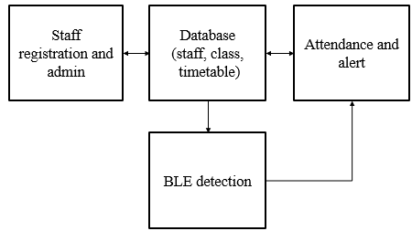
Fig 4.1 Block Diagram
Block Diagram Description
The block diagram illustrates the overall workflow of the proposed Context-Aware Indoor Staff Presence Verification using BLE system. It represents the sequence of operations starting from signal transmission to final presence detection.

BLE Beacon Module
The BLE beacon module is responsible for transmitting signals continuously within the indoor environment. Each beacon broadcasts a unique identifier, which helps in distinguishing different locations.
These signals act as the primary source for detecting user presence.

Mobile Device / Receiver Module
The mobile device or IoT receiver detects signals from nearby BLE beacons. It measures the signal strength in terms of RSSI and records relevant data such as timestamp and device information.
This module acts as the interface between the user and the system.

Data Collection Module
In this stage, all received data including RSSI values, beacon IDs, and timestamps are collected and stored. This data forms the raw dataset required for further processing.

Pre-processing Module
The collected data is pre-processed to remove noise and improve signal quality. Techniques such as filtering, smoothing, and normalization are applied to handle fluctuations in RSSI values.
This step ensures that the data is reliable and suitable for analysis.

Feature Extraction Module
Feature extraction is performed to identify meaningful patterns from the processed data. Important features such as average RSSI, signal variance, and duration of presence are extracted.
These features help in representing the data effectively for classification.

Machine Learning Classification Module
In this module, machine learning algorithms are used to classify whether a user is present or not. The model is trained using labeled data and learns patterns based on extracted features.
It predicts the presence status based on input data.

Context-Aware Module
The context-aware module enhances system accuracy by considering additional factors such as time duration, signal stability, and user movement patterns.
This helps in reducing false detections and improving decision-making.

CHAPTER 5
RESULTS

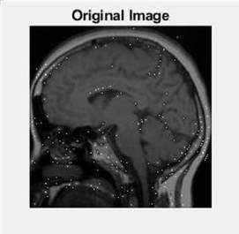
Fig 5.1 Original MRI Image of Brain Tumor
In Fig 5.1 the image represents the raw MRI scan showcasing the anatomical structure of the brain with the presence of a tumor highlighted. It serves as the baseline for subsequent analysis and provides an initial visual representation of the tumor's location and characteristics within the brain.

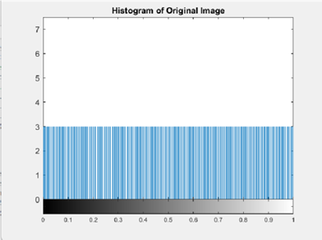
Fig 5.2 Histogram of Original Image

In Fig 5.2 the image displays the distribution of pixel intensities within the MRI scan, offering insights into the overall contrast and brightness levels present in the image. This histogram serves as a visual summary of the image's intensity distribution, aiding in the assessment of image quality and providing valuable information for subsequent image processing and analysis.

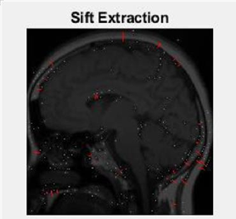
Fig 5.3 Image after using SIFT Extraction
In Fig 5.3 the image highlights distinctive features present in the original MRI scan. SIFT extraction identifies key points within the image that are invariant to scale and rotation, providing a detailed representation of local structures and patterns. This processed image serves as a feature-rich representation, enabling subsequent analysis for tasks such as image matching and object recognition.

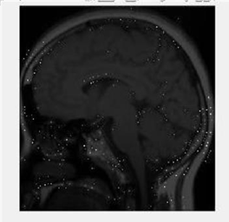
Fig 5.4 Image after feature extraction
In Fig 5.4 the image reveals salient characteristics extracted from the original MRI scan, such as texture, shape, and intensity information. This processed image encapsulates key features relevant to tumor detection, facilitating subsequent analysis and classification tasks. Feature extraction enhances the discriminative power of the image representation, enabling effective identification and characterization of tumor regions within the brain.

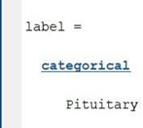
Fig 5.5 Tumor Classification
In Fig 5.5 the image categorizes regions within the MRI scan as either tumor or non-tumor, based on the output of a classification algorithm. It also categorizes the type of tumor identified. This categorization provides valuable insights for medical professionals in diagnosing and treating brain tumors.

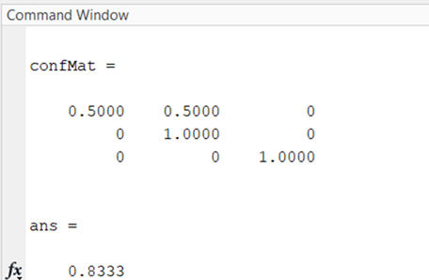
Fig 5.6 Confusion Matrix

In Fig 5.6 the image displays the confusion matrix which visualizes the performance of the classification algorithm by presenting the counts of true positive, true negative, false positive, and false negative predictions. Each cell of the matrix quantifies the accuracy of the classifier's predictions compared to the ground truth labels. This visualization aids in evaluating the classifier's performance, identifying areas of strength and areas for improvement, and informing decisions regarding the algorithm's effectiveness in brain tumor detection.

CHAPTER 6
CONCLUSION AND FUTURE SCOPE
Conclusion:
An early and accurate diagnosis of brain tumors is crucial for improving patient outcomes. To address this, the proposed model presents an automated method for classifying different types of brain tumors with high accuracy. The approach involves using a Support Vector Machine (SVM) model, which was found to outperform other standard classification methods including KNN, decision tree, and random forest. This superiority was determined based on the weighted average of precision and accuracy measures. Thus, the suggested SVM model shows great potential as an effective and efficient solution for the precise classification of brain tumors. The algorithm speeds up the process and enhances the likelihood of finding the proper kind of tumor. The model makes predictions and provides results more quickly, which aids in diagnosis and treatment. Using the SVM model yielded the following accuracy: With the training dataset it was 93%, while for the testing dataset, it was 92%. Nine of the ten given photos were correctly classified. By offering a larger dataset for training, the model's precision can be increased even more. The effectiveness of the model can be increased by classifying different types of brain tumors. Due to its diversity, this application may be utilized for medical purposes, speeding up the detecting process.

In conclusion, the implementation of brain tumor detection using MRI images holds immense significance across numerous domains of healthcare, research, and patient care. Through the integration of advanced imaging technology, computational algorithms, and multidisciplinary collaboration, MRI-based approaches contribute to early diagnosis, personalized treatment planning, and improved outcomes for individuals affected by brain tumors. Moreover, MRI-based brain tumor detection has implications beyond clinical practice, extending into education, training, public health, and epidemiology. By enhancing our understanding of tumor biology, epidemiology, and population health trends, MRI imaging contributes to informed decision-making, resource allocation, and public health policies aimed at addressing the global burden of brain tumors.

Future Scope:
In the realm of brain tumor detection using MRI images, the field presents a rich landscape for future exploration and innovation. Advancements in machine learning algorithms, particularly deep learning architectures like convolutional neural networks (CNNs), offer promising avenues for enhanced accuracy and efficiency in tumor detection. Research efforts could focus on refining existing algorithms or developing novel approaches that leverage the vast amounts of MRI data available for training. Additionally, the integration of multi-modal imaging techniques, such as combining MRI with positron emission tomography (PET) or functional MRI (fMRI), holds potential for capturing complementary information and improving the overall diagnostic capability. Furthermore, the application of artificial intelligence in real-time or point-of-care settings could revolutionize clinical practice by providing rapid and accurate diagnoses, enabling timely interventions and personalized treatment strategies. As technology continues to evolve and interdisciplinary collaborations flourish, the future of brain tumor detection using MRI images is poised to usher in transformative breakthroughs in healthcare.

CHAPTER 7
APPENDIX
7.1 Sample Code:
Training.m
clear all
close all
clc
l=0;
% Define a starting folder.
start_path = 'Training\';
% Ask user to confirm or change.
topLevelFolder = start_path;
if topLevelFolder == 0
return;
end
% Get list of all subfolders.
allSubFolders = genpath(topLevelFolder);
% Parse into a cell array.
remain = allSubFolders;
listOfFolderNames = {};
while true
[singleSubFolder, remain] = strtok(remain, ';');%#ok (suppres m-lint warning)
if isempty(singleSubFolder)
break;
end
listOfFolderNames = [listOfFolderNames singleSubFolder];%#ok (suppres m-lint warning)
end
numberOfFolders = length(listOfFolderNames);
totalFileList={};%this will contain all file names of jpg files
% Process all image files in those folders.
for k = 1 : numberOfFolders
% Get this folder and print it out.
if(k~=numberOfFolders)
k=k+1;
thisFolder = listOfFolderNames{k};
%fprintf('Processing folder %s\n', thisFolder);

% Get JPG files.
filePattern = sprintf('%s/*.jpg', thisFolder);
baseFileNames = dir(filePattern);
numberOfImageFiles = length(baseFileNames);
% Now we have a list of all files in this folder.
if numberOfImageFiles >= 1
% Go through all those image files.
for f = 1 : numberOfImageFiles
fullFileName = fullfile(thisFolder, baseFileNames(f).name);
totalFileList{end+1}=fullFileName;%#ok (suppres m-lint warning)
fprintf(' Processing image file %s\n', fullFileName);
mydata{k}=imread(fullFileName);

I2=mydata{k};
I2=imresize(I2,[200 200]);
l=k-1;
I2=sift(I2);
% mkdir(strcat('Person',int2str(l)));
folder='E:\2019-20\IMAGE PROJECTS\BRAIN_TUMOUR CLASSIFICATION\Extended Training\'
if(l==1)
imwrite(I2,fullfile(strcat(folder,'Glioma','\'),baseFileNames(f).name));
end
if(l==2)
imwrite(I2,fullfile(strcat(folder,'Meningioma','\'),baseFileNames(f).name));
end

if(l==3)
imwrite(I2,fullfile(strcat(folder,'Pituitary','\'),baseFileNames(f).name));
end
end

else
%fprintf(' Folder %s has no image files in it.\n', thisFolder);
end
end
end
dir='E:\2019-20\IMAGE PROJECTS\BRAIN_TUMOUR CLASSIFICATION'
outputFolder = fullfile(dir, ''); % define output folder

rootFolder = fullfile(outputFolder, 'Extended Training');
categories = {'Glioma','Meningioma','Pituitary'};
imds = imageDatastore(fullfile(rootFolder, categories), 'LabelSource', 'foldernames');
tbl = countEachLabel(imds);
minSetCount = min(tbl{:,2}); % determine the smallest amount of images in a category
imds = splitEachLabel(imds, minSetCount, 'randomize');

countEachLabel(imds)

Pituitary = find(imds.Labels == 'Pituitary', 1);
Meningioma = find(imds.Labels == 'Meningioma', 1);
Glioma = find(imds.Labels == 'Glioma', 1);

figure()
subplot(1,3,1);
imshow(readimage(imds,Pituitary))
subplot(1,3,2);
imshow(readimage(imds,Meningioma))
subplot(1,3,3);
imshow(readimage(imds,Glioma))

net = resnet50();

set(gca,'YLim',[150 170]);

net.Layers(1)

net.Layers(end)

numel(net.Layers(end).ClassNames)

[trainingSet, testSet] = splitEachLabel(imds, 0.3, 'randomize');
imageSize = net.Layers(1).InputSize;
augmentedTrainingSet = augmentedImageDatastore(imageSize, trainingSet, 'ColorPreprocessing', 'gray2rgb');
augmentedTestSet = augmentedImageDatastore(imageSize, testSet, 'ColorPreprocessing', 'gray2rgb');
w1 = net.Layers(2).Weights;

w1 = mat2gray(w1);
w1 = imresize(w1,5);

featureLayer = 'fc1000';
trainingFeatures = activations(net, augmentedTrainingSet, featureLayer, ...
'MiniBatchSize', 32, 'OutputAs', 'columns');
clc
close all

Testing.m
clc
close all
clear dir
trainingLabels = trainingSet.Labels;

classifier = fitcecoc(trainingFeatures, trainingLabels, ...
'Learners', 'Linear', 'Coding', 'onevsall', 'ObservationsIn', 'columns');

testFeatures = activations(net, augmentedTestSet, featureLayer, ...
'MiniBatchSize', 32, 'OutputAs', 'columns');

% Pass CNN image features to trained classifier
predictedLabels = predict(classifier, testFeatures, 'ObservationsIn', 'columns');
% Get the known labels
testLabels = testSet.Labels;
% Tabulate the results using a confusion matrix.
confMat = confusionmat(testLabels, predictedLabels);
% Convert confusion matrix into percentage form
confMat = bsxfun(@rdivide,confMat,sum(confMat,2))
% Display the mean accuracy
mean(diag(confMat))
newImage=imread('1.jpg');
figure,imshow(newImage);
title('Original Image');
I3 = newImage;
I3=imresize(I3,[200 200]);
si=ndims(I3);
if(si>2)
gray=rgb2gray(I3);figure,imshow(gray);
title('Gray Image');
end
figure,imhist(gray);
title('Histogram of Original Image');

I3=sift(I3);
% Create augmentedImageDatastore to automatically resize the image when
% image features are extracted using activations.
ds = augmentedImageDatastore(imageSize, I3, 'ColorPreprocessing', 'gray2rgb');
% Extract image features using the CNN
imageFeatures = activations(net, ds, featureLayer, 'OutputAs', 'columns');
%%% Make a prediction using the classifier
disp(imageFeatures)
label = predict(classifier, imageFeatures, 'ObservationsIn', 'columns')
if(label=='Glioma')
imagefiles = 'E:\2019-20\IMAGE PROJECTS\BRAIN_TUMOUR CLASSIFICATION\Grades';
imgcount = 0;
D = dir(fullfile(imagefiles,'*.jpg'));
for i=1 : size(D,1)
if not(strcmp(D(i).name,'.')|strcmp(D(i).name,'..')|strcmp(D(i).name,'Thumbs.db'))
imgcount = imgcount + 1; % Number of all images in the training database
end
end

X = [];
for i = 1 : imgcount

str = strcat(imagefiles,'\',int2str(i),'.jpg');
currentimage = imread(str);
images{i} = currentimage;
images{i} = im2double(images{i});
Si=ndims(images{i});
if Si>2
images{i}=rgb2gray(images{i}); %Convert the Three Layered Image into Intensity Image with Grey Value
else

end

images{i} = imresize(images{i},[200 200]);
images{i} = reshape(images{i}', 1, size(images{i},1)*size(images{i},2));
end

trainData = zeros(imgcount, 40000);

for ii=1:imgcount
trainData(ii,:) = images{ii};
end

inputImg=newImage;
inputImg = im2double(inputImg);

Si=ndims(inputImg);
if Si>2
inputImg=rgb2gray(inputImg);

end
inputImg = imresize(inputImg, [200 200]);
inputImg = reshape (inputImg', 1, size(inputImg,1)*size(inputImg,2));
C=[1 2 3]
rs=multisvm(trainData,C,inputImg);
disp(rs);
if(rs==1)
f = msgbox('Grade 1 Glioma detected');
end
if(rs==2)
f = msgbox('Grade 2 Glioma detected');
end
if(rs==3)
f = msgbox('Grade 3 Glioma detected');
end
end

multisvm.m
function [itrfin] = multisvm( T,C,test )
%MULTISVM(3.0) classifies the class of given training vector according to the
% given group and gives us result that which class it belongs.
% We have also to input the testing matrix

%Inputs: T=Training Matrix, C=Group, test=Testing matrix
%Outputs: itrfin=Resultant class(Group,USE ROW VECTOR MATRIX) to which tst set belongs
itrind=size(test,1);
itrfin=[];
Cb=C;
Tb=T;
for tempind=1:itrind
tst=test(tempind,:);
C=Cb;
T=Tb;
u=unique(C);
N=length(u);
c4=[];
c3=[];
j=1;
k=1;
if(N>2)
itr=1;
classes=0;
cond=max(C)-min(C);
while((classes~=1)&&(itr<=length(u))&& size(C,2)>1 && cond>0)
%This while loop is the multiclass SVM Trick
c1=(C==u(itr));
newClass=c1;
% svmStruct = svmtrain(T,newClass,'kernel_function','rbf'); % I am using rbf kernel function, you must change it also
svmStruct = fitcsvm(T,newClass,'KernelFunction','rbf')

classes = predict(svmStruct,tst);

% This is the loop for Reduction of Training Set
for i=1:size(newClass,2)
if newClass(1,i)==0;
c3(k,:)=T(i,:);
k=k+1;
end
end
T=c3;
c3=[];
k=1;

% This is the loop for reduction of group
for i=1:size(newClass,2)
if newClass(1,i)==0;
c4(1,j)=C(1,i);
j=j+1;
end
end
C=c4;
c4=[];
j=1;

cond=max(C)-min(C); % Condition for avoiding group
%to contain similar type of values
%and the reduce them to process

% This condition can select the particular value of iteration
% base on classes
if classes~=1
itr=itr+1;
end
end
end

valt=Cb==u(itr); % This logic is used to allow classification
val=Cb(valt==1); % of multiple rows testing matrix
val=unique(val);
itrfin(tempind,:)=val;
end
end

sift.m
function [k1] = sift(img)
%UNTITLED3 Summary of this function goes here
% Detailed explanation goes here

[~,~,ColorChannel] = size(img);
if ColorChannel > 1
img = rgb2gray(img);
end
img = double(img)/255;
ScaleSpaceNum = 3; % number of scale space intervals
SigmaOrigin = 2^0.5; % default sigma
ScaleFactor = 2^(1/ScaleSpaceNum);
StackNum = ScaleSpaceNum + 3; % number of stacks = number of scale space intervals + 3
OctaveNum = 3;
GaussianFilterSize = 21;
OctaveImage = {OctaveNum,StackNum}; % save the Gaussian-filtered results of image
OctaveImageDiff = {OctaveNum,StackNum-1}; % save the Difference of Gaussian-filtered results of image

%% Gaussian Convolution of Images in Each Octave
ImgOctave = cell(OctaveNum,1);
for Octave = 1:OctaveNum
Sigma = SigmaOrigin * 2^(Octave-1); % when up to a new octave, double the sigma
ImgOctave{Octave} = imresize(img, 2^(-(Octave-1)));
for s = 1:StackNum
SigmaScale = Sigma * ScaleFactor^(s-2);
% calculate Guassian kernel
GaussianFilter = fspecial('gaussian',[GaussianFilterSize,GaussianFilterSize],SigmaScale);
% do convolution with Gassian kernel
OctaveImage{Octave,s} = imfilter(ImgOctave{Octave}, GaussianFilter,'symmetric');
end
end
% calculate difference of Gaussian (in original paper eq.1)
for Octave = 1:OctaveNum
for s = 1:StackNum-1
OctaveImageDiff{Octave,s} = OctaveImage{Octave,s+1} - OctaveImage{Octave,s};
end
end
%% Find the local minima and maxima between stacks
DiffMinMaxMap = cell(OctaveNum,StackNum-3);
for Octave = 1:OctaveNum
for s = 2:size(OctaveImageDiff,2)-1
CompareDiffImg = zeros(size(OctaveImage{Octave,1},1)-2,size(OctaveImage{Octave,1},2)-2,27);
indx = 0; % 3rd dimension indx for CompareDiffImg
for s2 = s-1:s+1
for k = 1:9
[i,j] = ind2sub([3,3],k);
CompareDiffImg(:,:,indx+k) = OctaveImageDiff{Octave,s2}(i:end-3+i,j:end-3+j);
end
indx = indx + 9;
end
[~,MinMap] = min(CompareDiffImg,[],3);
MinMap = (MinMap == 14);
[~,MaxMap] = max(CompareDiffImg,[],3);
MaxMap = (MaxMap == 14);
DiffMinMaxMap{Octave,s-1} = MinMap + MaxMap; % the center indx is 9 + 5 = 14
end
end

%% Accurate keypoint localization
UnstableExtremaThreshold = 0.03; % set the threshold as 0.03 (the same as the original paper)
DiffMinMaxMapAccurate = DiffMinMaxMap;
for Octave = 1:OctaveNum
Sigma = SigmaOrigin * 2^(Octave-1);
for DiffMinMaxMapIndx = 1:size(DiffMinMaxMap,2)
Map = DiffMinMaxMap{Octave,DiffMinMaxMapIndx};
SSCindx = find(Map); % Scale-Space-Corner Index
if isempty(SSCindx)
continue;
end
for ssc = 1:length(SSCindx)
[Row,Col] = ind2sub([size(Map,1),size(Map,2)], SSCindx(ssc));
if (Row <= 1) || (Row >= size(Map,1)) || (Col <= 1) || (Col >= size(Map,2))
DiffMinMaxMapAccurate{Octave,DiffMinMaxMapIndx}(Row,Col) = 0; % discard out of matrix boundary
continue;
end
RowDiff = OctaveImageDiff{Octave,DiffMinMaxMapIndx+1}(Row+1,Col) - OctaveImageDiff{Octave,DiffMinMaxMapIndx+1}(Row-1,Col);
ColDiff = OctaveImageDiff{Octave,DiffMinMaxMapIndx+1}(Row,Col+1) - OctaveImageDiff{Octave,DiffMinMaxMapIndx+1}(Row,Col-1);
ScaleDiff = OctaveImageDiff{Octave,DiffMinMaxMapIndx+2}(Row,Col) - OctaveImageDiff{Octave,DiffMinMaxMapIndx}(Row,Col);
offset = [2; 2; Sigma * ScaleFactor^(DiffMinMaxMapIndx) - Sigma * ScaleFactor^(DiffMinMaxMapIndx-2)];
DxHat = OctaveImageDiff{Octave,DiffMinMaxMapIndx+1}(Row,Col) + 0.5 * ([RowDiff,ColDiff,ScaleDiff] * offset);
if abs(DxHat) < UnstableExtremaThreshold
DiffMinMaxMapAccurate{Octave,DiffMinMaxMapIndx}(Row,Col) = 0; % discard unstable extrema
end
end
end
end
%% Eliminating edge responses
gamma = 10; % set the threshold gamma as 10 (the same as the original paper)
DetermineThreshold = (gamma + 1)^2 / gamma;
DiffMinMaxMapNoEdge = DiffMinMaxMapAccurate;
for Octave = 1:OctaveNum
for DiffMinMaxMapIndx = 1:size(DiffMinMaxMap,2)
Map = DiffMinMaxMapAccurate{Octave,DiffMinMaxMapIndx};
SSCindx = find(Map); % Scale-Space-Corner Index
if isempty(SSCindx)
continue;
end
for ssc = 1:length(SSCindx)
[Row,Col] = ind2sub([size(Map,1),size(Map,2)], SSCindx(ssc));
if (Row <= 1) || (Row >= size(Map,1)) || (Col <= 1) || (Col >= size(Map,2))
DiffMinMaxMapNoEdge{Octave,DiffMinMaxMapIndx}(Row,Col) = 0; % discard out of matrix boundary
continue;
end
Dyy = OctaveImageDiff{Octave,DiffMinMaxMapIndx+1}(Row+1,Col) - 2*OctaveImageDiff{Octave,DiffMinMaxMapIndx+1}(Row,Col) + OctaveImageDiff{Octave,DiffMinMaxMapIndx+1}(Row-1,Col);
Dxx = OctaveImageDiff{Octave,DiffMinMaxMapIndx+1}(Row,Col+1) - 2*OctaveImageDiff{Octave,DiffMinMaxMapIndx+1}(Row,Col) + OctaveImageDiff{Octave,DiffMinMaxMapIndx+1}(Row,Col-1);
Dxy = OctaveImageDiff{Octave,DiffMinMaxMapIndx+1}(Row-1,Col+1) - OctaveImageDiff{Octave,DiffMinMaxMapIndx+1}(Row-1,Col-1) - OctaveImageDiff{Octave,DiffMinMaxMapIndx+1}(Row+1,Col+1) + OctaveImageDiff{Octave,DiffMinMaxMapIndx+1}(Row+1,Col-1);
TrH = Dxx + Dyy;
DetH = Dxx*Dyy - Dxy^2;
if ((TrH^2 / DetH) >= DetermineThreshold)
DiffMinMaxMapNoEdge{Octave,DiffMinMaxMapIndx}(Row,Col) = 0; % discard unstable extrema
end
end
end
end

%% SIFT feature descriptors generation
% the patch size for dominant orientation calculation is 9;
% the patch size for feature transformation is 16;
DominantOrientation = cell(size(DiffMinMaxMap));
SIFT = cell(size(DiffMinMaxMap));
for Octave = 1:OctaveNum
Sigma = SigmaOrigin * 2^(Octave-1); % when up to a new octave, double the sigma
for DiffMinMaxMapIndx = 1:size(DiffMinMaxMap,2)
stack = DiffMinMaxMapIndx+1;
SigmaScale = Sigma * ScaleFactor^(stack-2);
GaussianSmoothedImage = OctaveImage{Octave,stack};
Map = DiffMinMaxMapNoEdge{Octave,DiffMinMaxMapIndx};
SSCindx = find(Map); % Scale-Space-Corner Index
if isempty(SSCindx)
continue;
end
DomOri = zeros(length(SSCindx),2,36); % first column is for sita, second column is for magnitude
sift = zeros(length(SSCindx),128,36);
for ssc = 1:length(SSCindx)
[Row,Col] = ind2sub([size(Map,1),size(Map,2)], SSCindx(ssc));
Row = Row+1; Col = Col+1; % offset = [1,1];
if (Row <= 10) || (Row >= size(GaussianSmoothedImage,1)-8) || (Col <= 10) || (Col >= size(GaussianSmoothedImage,2)-8)
% skip if out of boundary
continue;
end
sitaquantize = mod(sita(5:13,5:13) + pi/36,2*pi);
sitaquantize = floor(sitaquantize / (2*pi/36));
sitabin = zeros(36,1);
for patchindx = 1:9^2
sitabin(sitaquantize(patchindx)+1) = sitabin(sitaquantize(patchindx)+1) + Dmag(patchindx);
end
7.2 Sample Screenshots
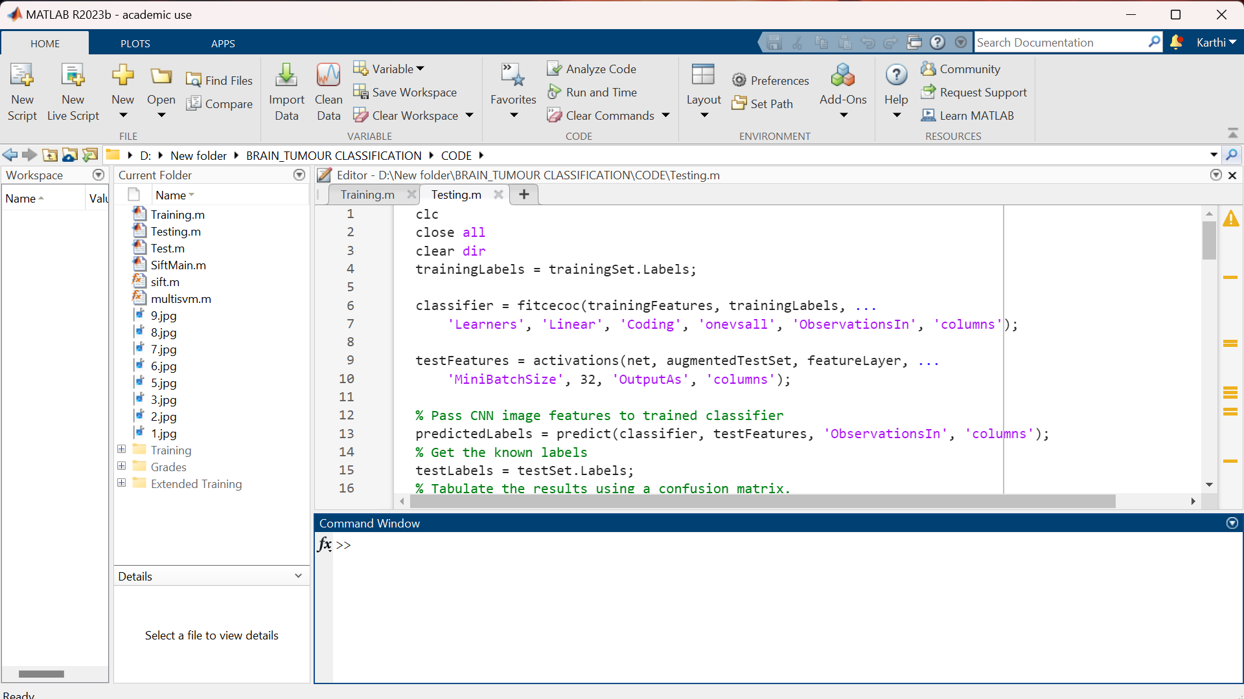
Fig 7.2.1 Testing Code 1
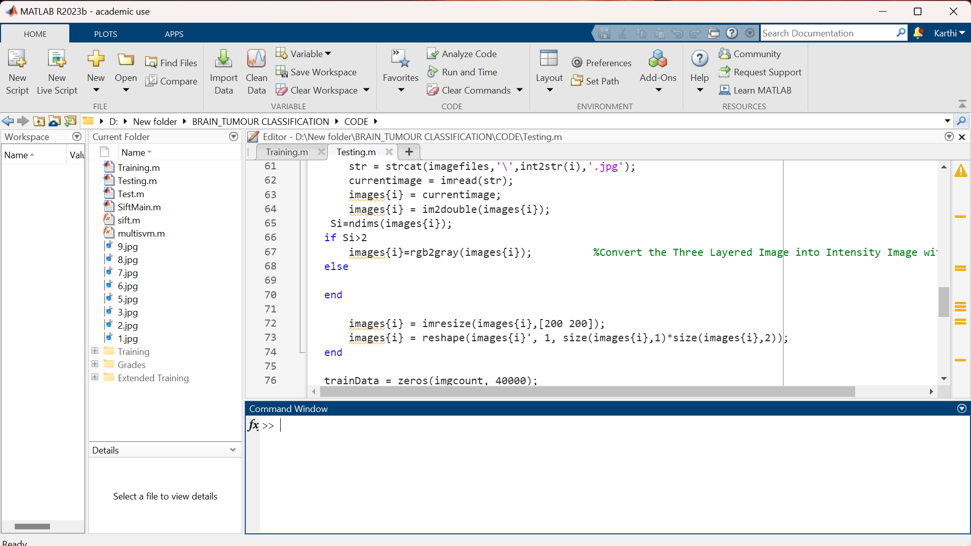
Fig 7.2.2 Testing Code 2
Fig 8.2.1 and 8.2.2 represents the testing code which is used to test and evaluate the SVM model after it is trained.
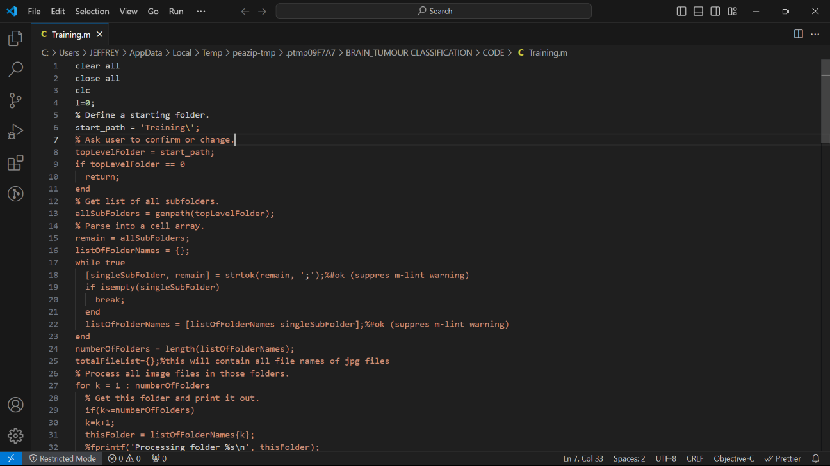
Fig 7.2.3 Training Code 1
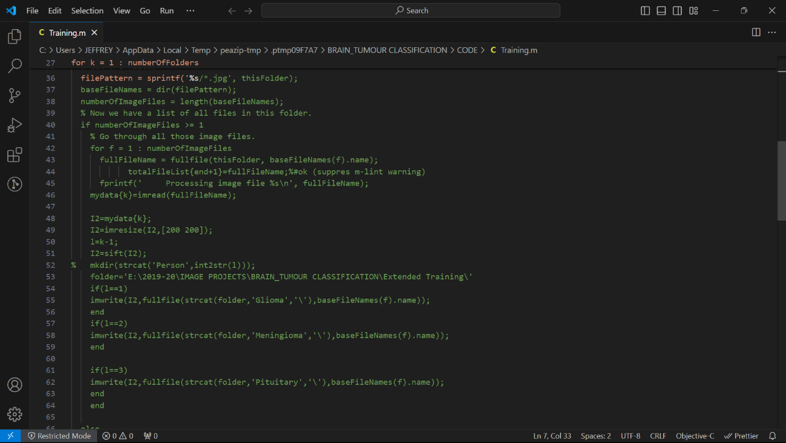
Fig 7.2.4 Training Code 2
Fig 8.2.3 and 8.2.4 represents the training code which is used to train the SVM model to classify the tumor types.

8. REFERENCES
- Abdulbaqi, Hayder Saad, MohdZubir Mat, Omar, Ahmad Fairuz, Mustafa, Iskandar Shahrim Bin, Abood, LoayKadom, “Detecting brain tumor in Magnetic Resonance Images using Hidden Markov Random Fields and Threshold techniques”, IEEE Student Conference on Research and Development,2014.
- Hamad, Yousif A,Simonov, Konstantin, Naeem, Mohammad B “Brain's Tumor Edge Detection on Low Contrast Medical Images” , IEEE 1st Annual International Conference on Information and Sciences (AiCIS),2018.
- Hirahara, Daisuke “Preliminary assessment for the development of CADe system for brain tumor in MRI images utilizing transfer learning in Xception model”, IEEE 8th Global Conference on Consumer Electronics (GCCE) - Osaka, Japan,2019.
- Kumar, Sa Bijay, Panda, Rutuparna, Agrawal, Sanjay, “Brain Magnetic Resonance Image Tumor Detection and Segmentation Using Edgeless Active Contour”, IEEE 11th International Conference on Computing, Communication and Networking Technologies (ICCCNT) - Kharagpur, India, 2020.
- Mathew, A Reema,Anto, P Babu , “Tumor detection and classification of MRI brain image using wavelet transform and SVM” , IEEE International Conference on Signal Processing and Communication (ICSPC) -Coimbatore,India , 2017.
- Nandi, Anupurba , “Detection of human brain tumour using MRI image segmentation and morphological operators” , IEEE International Conference on Computer Graphics, Vision and Information Security (CGVIS) - Bhubaneshwar, Odisha, India , 2015.
- Parveen, Singh, Amritpal, “Detection of brain tumor in MRI images, using combination of fuzzy c-means and SVM”, IEEE 2nd International Conference on Signal Processing and Integrated Networks (SPIN) - Noida, Delhi-NCR, India, 2015.
- Sahu, Yogesh Kumar, Pandey, Chanki, Biswas, Preesat, Khan, M.R., Rathore, Shanti, “Minimum Time Delay and More Efficient Image Filtering Brain Tumour Detection with the help of MATLAB”, IEEE International Conference on Communication and Signal Processing (ICCSP) - Chennai, India, 2020.
- Singh, Baljinder; Aggarwal, Pankaj “Detection of brain tumor using modified mean-shift based fuzzy c-mean segmentation from MRI Images”, 8th IEEE Annual Information Technology, Electronics and Mobile Communication Conference (IEMCON), Vancouver, BC, 2017.
- Zawish, Muhammad, Siyal, Asad Ali, Ahmed, Kainat, Khalil, Aiman, Memon, Sheeraz, “Brain Tumor Segmentation in MRI images using Chan-Vese Technique in MATLAB, Quetta, Pakistan , 2018.
- M. Havaei et al., “Brain tumor segmentation with deep neural networks,” Med. Image Anal., vol. 35, 2017.
- Deepa and W. S. Emmanuel, “An efficient detection of brain tumor using fused feature adaptive firefly backpropagation neural network,” Multimedia Tools Appl., vol. 78, no. 9, 2019.
- Y. Jiang, J. Hou, X. Xiao, and H. Deng, “A brain tumor segmentation new method based on statistical thresholding and multiscale CNN,” in Proc. Int. Conf. Intell. Comput., 2018.
- W. Deng, Q. Shi, K. Luo, Y. Yang, and N. Ning, “Brain tumor segmentation based on improved convolutional neural network in combination with non-quantifiable local texture feature,” J. Med. Syst., vol. 43, no. 6, 2019.
- H. Dong, G. Yang, F. Liu, Y. Mo, and Y. Guo, “Automatic brain tumor detection and segmentation using u-net based fully convolutional networks,” in Proc. Annu. Conf. Med. Image Understanding Anal., 2017.



